STUDENT PROGRESS LEARNING TRACKER

Team Members
1.Yepuri Duhya Sri (Team lead)-Roll.No.25A31A05AA
2.Ponnaluri Kejiya-Roll.No.25A31A0595
3.Setti Pushpa Hasini-Roll.No.25A311A0596
4.Vempada Durgareddy-Roll.No.25A31A05BE
5.Vasarla Tarun Vinay-Roll.No.25A31A05BD

Guided By
Mr. Y. Manas Kumar
Assistant Professor
CSE Department
Pragati Engineering College (A), Surampalem

1. Project Description

System Learning Progress Tracker - Project Description
Overview
The System Learning Progress Tracker is a comprehensive web-based application designed to help students, professionals, and lifelong learners monitor and visualize their educational journey across multiple subjects or skill areas. This intelligent tracking system transforms the often-overwhelming task of managing personal development into an organized, motivating, and data-driven experience.
In an era of continuous learning and skill development, individuals often struggle to maintain consistent progress across multiple educational pursuits. The System Learning Progress Tracker addresses this challenge by providing a centralized platform where users can set learning goals, track their daily progress, analyze patterns in their study habits, and celebrate achievements. The primary objective is to increase learning effectiveness through better self-awareness and accountability.
The application offers a rich feature set including course or subject management, where users can create and organize different learning paths with customizable categories and difficulty levels. The progress tracking module allows learners to log study sessions, record completion percentages, and mark milestones. An intuitive dashboard provides real-time visualizations through charts and graphs, displaying metrics such as time invested per subject, weekly progress trends, and completion rates.
Goal-setting functionality enables users to establish both short-term and long-term objectives, with automatic reminders and deadline tracking. The system calculates estimated completion dates based on current learning velocity, helping users make realistic commitments. A notes and resources section allows learners to document key insights, attach reference materials, and maintain a personalized knowledge base.
The tracker will be built using modern web technologies ensuring responsiveness across desktop and mobile devices. The frontend utilizes HTML5, CSS3, and JavaScript with frameworks like React for dynamic user interfaces. Data visualization components leverage libraries such as Chart.js or Recharts to create engaging visual representations of progress. The backend can be developed using Node.js or Python, with data persistence handled through either local storage for lightweight implementations or database solutions like MongoDB or PostgreSQL for more robust versions.
The application prioritizes simplicity and motivation in its design. Users are greeted with a clean dashboard showing their overall learning statistics and immediate next steps. Color-coded progress indicators provide quick visual feedback, while achievement badges and streak counters gamify the learning process to maintain engagement. The interface supports both light and dark modes for comfortable viewing during extended study sessions.
By implementing the System Learning Progress Tracker, users gain clarity about their learning habits, identify subjects requiring more attention, and maintain consistent momentum toward their educational goals. The data-driven insights help optimize study schedules, while the visual progress indicators provide psychological reinforcement that sustains motivation through challenging learning periods.
Potential expansions include AI-powered recommendations for study focus areas, integration with popular learning platforms, collaborative features for study groups, and advanced analytics using machine learning to predict optimal learning patterns. Mobile applications could add offline capabilities and push notifications for enhanced accessibility.
This comprehensive tracking system transforms personal learning from a passive activity into an actively managed, measurable, and rewarding journey toward mastery.

2. System Architecture
The system architecture of the Student Learning Progress Tracker is designed to performance data and evaluate learning patterns.collect, process, store, and present student performance data in an efficient and user-friendly way. The architecture mainly consists of four layers: User Interface Layer, Application/Logic Layer, Database Layer, and Output/Reporting Layer. The User Interface Layer allows students and teachers to interact with the system. Students can enter marks, view progress, and monitor improvements, while teachers can update The Application/Logic Layer processes the input data. It calculates averages, compares scores, categorizes performance (Excellent, Good, Average, Below Average, or Fail), and tracks improvements over time. This layer also handles validation to ensure the data entered is accurate.The Database Layer stores student details, marks, performance categories, and overall progress records. This ensures that data can be retrieved and updated whenever needed.Finally, the Output/Reporting Layer presents results through tables, graphs, or reports, helping users understand learning outcomes clearly.This architecture ensures accuracy, easy data management, and smooth tracking of student progress throughout the academic term.
Below is the architecture of our system: yes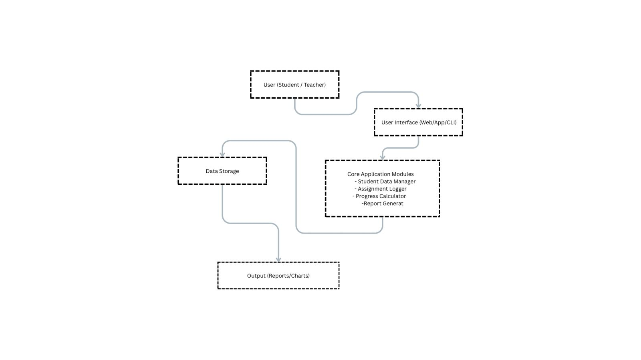
3.operational flowchart
Start
Read Marks for each Subject
Is marks valid
Calculate total marks
Initialize Arrays
Display Error message
Determine performance category
Did the student pass?
Add Subject to needs to improvement array

Add Subject to good performance array

Stop

